UML DESIGN (Earth)

UML DESIGN (Shuttle)

STRUCTURE CHARTS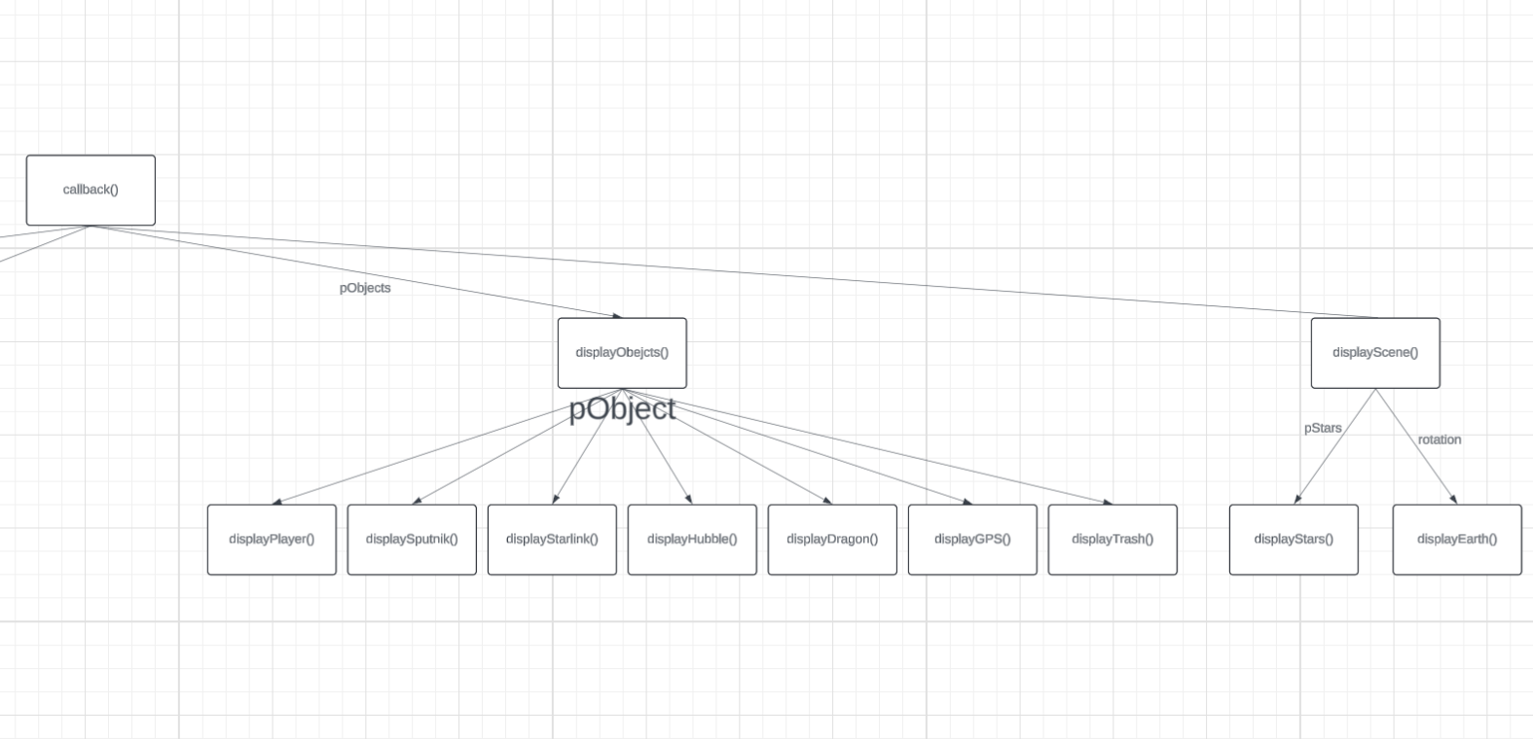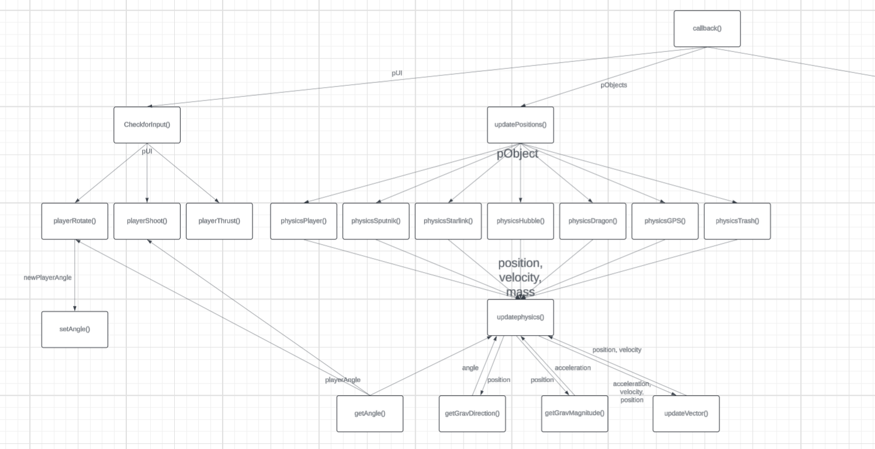

PSEUDOCODE

Function Break() : Satellite

FOR 0 -> numFragments

CREATE NEW Satellite:Fragment(

Position <- this.position + RANDOMOFFSET,

Velocity , <- this.velocity + RANDOMOFFSET)

ERASE this